Optimized Task Assignment and Freelancers Scheduling Using Hungarian Algorithm and CPM
M. Shaleni (24MDT1049), M. Keerthiga (24MDT1097) – MSc Data Science
1. Introduction
This project introduces an intelligent system designed to optimize freelancer assignments and project timelines. By applying the Hungarian Algorithm and Critical Path Method (CPM), it automates the matching of freelancers to tasks based on skills, cost, and availability, while also identifying time-sensitive tasks to ensure smooth, on-time project delivery.
  - Problem Statement
Freelance projects often face challenges in optimizing both resource allocation and time management. Assigning the right freelancer to the right task while keeping costs down and meeting deadlines is difficult without an intelligent system. This project introduces automation through mathematical optimization techniques to improve project efficiency.
2. Scope and Objectives
- Develop a cost-effective system to automatically assign freelancers to tasks based on skill match and experience.
- Optimize the overall project timeline by analysing task dependencies and identifying the critical path.
- Provide clear visualizations and generate comprehensive, downloadable reports for project tracking and presentation.

3. Methodology

3.1 Problem Definition
Two input CSV files are used: one for freelancer data (name, skill, cost, experience), and another for task data (task ID, name, required skill, duration, dependencies).

3.2 Optimization Approach
• The Hungarian Algorithm assigns freelancers to tasks with the lowest possible cost.
• CPM builds a task dependency graph and calculates timing constraints using forward and backward passes.
• Tasks with zero slack are flagged as critical.

3.3 Code Implementation
Python is used with libraries like pandas, numpy, networkx, matplotlib, and SciPy. Optimize. Key steps involve building a cost matrix, applying linear_sum_assignment for optimal matching, and using topological sorting to compute ES, EF, LS, LF, and slack for each task.

3.4 Visualization
The output graph uses color coding (red for critical path, blue for non-critical) and displays detailed ES/LS/Slack values below each task node.
Code :
!pip install gradio networkx matplotlib pandas scipy python-docx --quiet
import gradio as gr
import pandas as pd
import numpy as np
import networkx as nx
import matplotlib.pyplot as plt
from scipy.optimize import linear_sum_assignment
from docx import Document
from docx.shared import Pt, Inches
import tempfile
import matplotlib.patches as mpatches
# Added for legend
def format_table(doc, df, title):
doc.add_heading(title, level=2)
table = doc.add_table(rows=1, cols=len(df.columns))
table.style = 'Table Grid'
hdr_cells = table.rows[0].cells
for i, column_name in enumerate(df.columns):
hdr_cells[i].text = str(column_name)
hdr_cells[i].paragraphs[0].runs[0].font.bold = True
for _, row in df.iterrows():
row_cells = table.add_row().cells
for i, value in enumerate(row):
row_cells[i].text = str(value)
for paragraph in row_cells[i].paragraphs:
for run in paragraph.runs:
run.font.size = Pt(9)

def format_cost_matrix_table(doc, cost_matrix):
doc.add_heading(" Cost Matrix", level=2)
table = doc.add_table(rows=len(cost_matrix)+1, cols=len(cost_matrix[0])+1)
table.style = 'Table Grid'
table.cell(0, 0).text = ""
for j in range(len(cost_matrix[0])):
table.cell(0, j+1).text = f"T{j+1}"
for i in range(len(cost_matrix)):
table.cell(i+1, 0).text = f"F{i+1}"
for j in range(len(cost_matrix[0])):
table.cell(i+1, j+1).text = f"{cost_matrix[i][j]:.2f}"

def optimize_and_schedule(freelancer_file, task_file, budget):
freelancers = pd.read_csv(freelancer_file.name)
tasks = pd.read_csv(task_file.name)
num_freelancers = len(freelancers)
num_tasks = len(tasks)
max_dim = max(num_freelancers, num_tasks)
cost_matrix = np.full((max_dim, max_dim), 10000.0)
for i in range(num_freelancers):
for j in range(num_tasks):
f = freelancers.iloc[i]
t = tasks.iloc[j]
if f["Skill"].strip().lower() == t["Required Skill"].strip().lower():
cost_matrix[i][j] = f["Cost per Day"] / max(f["Experience (Years)"], 1)
row_ind, col_ind = linear_sum_assignment(cost_matrix)
assignments = []
total_cost = 0
for i, j in zip(row_ind, col_ind):
if i < num_freelancers and j < num_tasks and cost_matrix[i][j] < 9999:
f = freelancers.iloc[i]
t = tasks.iloc[j]
cost = f["Cost per Day"] * t["Duration (days)"]
total_cost += cost
assignments.append({
"Freelancer": f["Freelancer"],
"Skill": f["Skill"],
"Experience": f["Experience (Years)"],
"Task ID": t["Task ID"],
"Task Name": t["Task Name"],
"Cost/Day": f["Cost per Day"],
"Duration": t["Duration (days)"],
"Total Cost": cost
})
df_assignments = pd.DataFrame(assignments)
G = nx.DiGraph()
for _, row in tasks.iterrows():
G.add_node(row["Task ID"], name=row["Task Name"], duration=row["Duration (days)"])
for _, row in tasks.iterrows():
if pd.notna(row["Dependencies"]) and row["Dependencies"] != "":
for dep in str(row["Dependencies"]).split(","):
G.add_edge(dep.strip(), row["Task ID"])
for node in nx.topological_sort(G):
preds = list(G.predecessors(node))
G.nodes[node]["ES"] = max([G.nodes[p]["EF"] for p in preds], default=0)
G.nodes[node]["EF"] = G.nodes[node]["ES"] + G.nodes[node]["duration"]
project_duration = max(G.nodes[n]["EF"] for n in G.nodes)
for node in reversed(list(nx.topological_sort(G))):
succs = list(G.successors(node))
G.nodes[node]["LF"] = min([G.nodes[s]["LS"] for s in succs], default=project_duration)
G.nodes[node]["LS"] = G.nodes[node]["LF"] - G.nodes[node]["duration"]

critical_path = []
schedule_data = []
for node in G.nodes:
slack = G.nodes[node]["LS"] - G.nodes[node]["ES"]
schedule_data.append({
"Task": node,
"Name": G.nodes[node]["name"],
"ES": G.nodes[node]["ES"],
"EF": G.nodes[node]["EF"],
"LS": G.nodes[node]["LS"],
"LF": G.nodes[node]["LF"],
"Slack": slack
})
if slack == 0:
critical_path.append(node)
# Plot graph with styles and legend
pos = nx.spring_layout(G, seed=42)
plt.figure(figsize=(14, 10))
critical_edges = [(u, v) for u, v in G.edges() if u in critical_path and v in critical_path]
other_edges = [e for e in G.edges() if e not in critical_edges]

nx.draw_networkx_edges(G, pos, edgelist=other_edges, edge_color="black", width=2, arrowsize=20, style='dashed')
nx.draw_networkx_edges(G, pos, edgelist=critical_edges, edge_color="red", width=3.5, arrowsize=20, style='solid')
nx.draw_networkx_nodes(G, pos, node_color="lightblue", node_size=2500)
nx.draw_networkx_labels(G, pos)
# Legend for critical and non-critical paths
red_patch = mpatches.Patch(color='red', label='Critical Path')
black_patch = mpatches.Patch(color='black', label='Non-Critical Path (Dashed)')
plt.legend(handles=[red_patch, black_patch], loc='upper left', bbox_to_anchor=(1, 1))
plt.title(" Critical Path Visualization")
plt.axis('off')
graph_path = tempfile.NamedTemporaryFile(delete=False, suffix=".png").name
plt.savefig(graph_path)
plt.close()
# Generate Word Document
doc = Document()
doc.add_heading("Project Report", 0)
format_table(doc, freelancers, " Freelancer Data")
format_table(doc, tasks, " Task Data")
format_cost_matrix_table(doc, cost_matrix[:num_freelancers, :num_tasks])
format_table(doc, df_assignments, " Assignments (Hungarian Method)")
format_table(doc, pd.DataFrame(schedule_data), " CPM Task Schedule")
doc.add_heading("Critical Path Graph", level=2)
doc.add_picture(graph_path, width=Inches(8))
doc.add_heading(" Summary", level=2)
doc.add_paragraph(f" Total Assignment Cost: ${total_cost:.2f}")
if budget > 0:
if total_cost > budget:
doc.add_paragraph(f" Budget Exceeded by ${total_cost - budget:.2f}")
else:
doc.add_paragraph(f" Within Budget (${budget})")
doc.add_paragraph(f" Critical Path: {' → '.join(critical_path)}")
doc.add_paragraph(f" Project Duration: {project_duration} days")
word_path = tempfile.NamedTemporaryFile(delete=False, suffix=".docx").name
doc.save(word_path)
return df_assignments, pd.DataFrame(schedule_data), graph_path, word_path
# Gradio UI
demo = gr.Interface(
fn=optimize_and_schedule,
inputs=[
gr.File(label=" Upload Freelancer CSV"),
gr.File(label=" Upload Tasks CSV"),
gr.Number(label=" Enter Budget", value=0)
],
outputs=[
gr.Dataframe(label=" Assignment Results"),
gr.Dataframe(label=" CPM Schedule"),
gr.Image(label=" CPM Graph"),
gr.File(label=" Download Full Report (Word)")
],
title=" Freelancer Assignment + CPM Scheduler (Auto Report)",
description="Upload your freelancer & task files and get all analytics in a downloadable Word report."
)
demo.launch()

Inputs:
Freelancer data uploading:
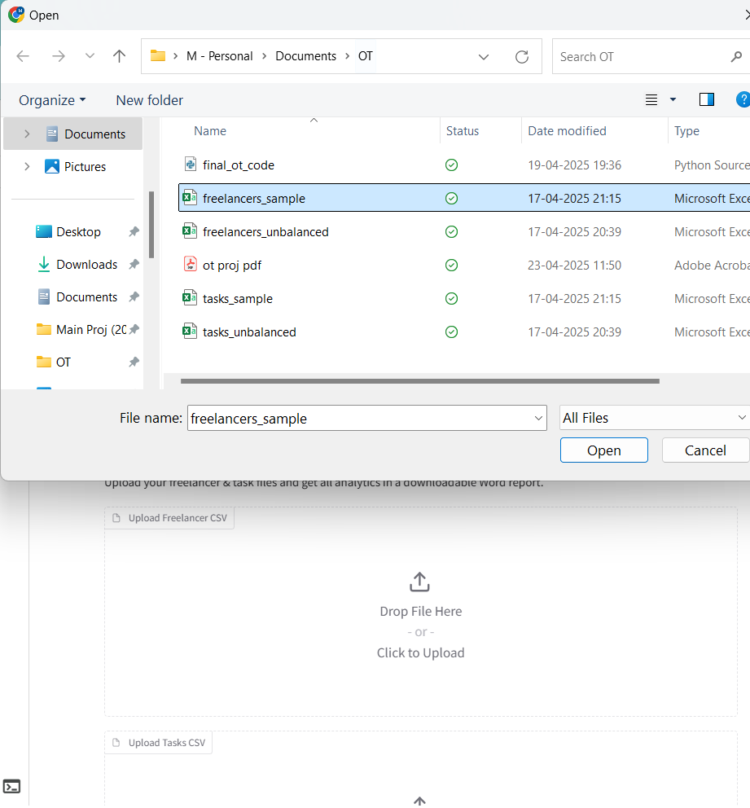
Task data uploading:
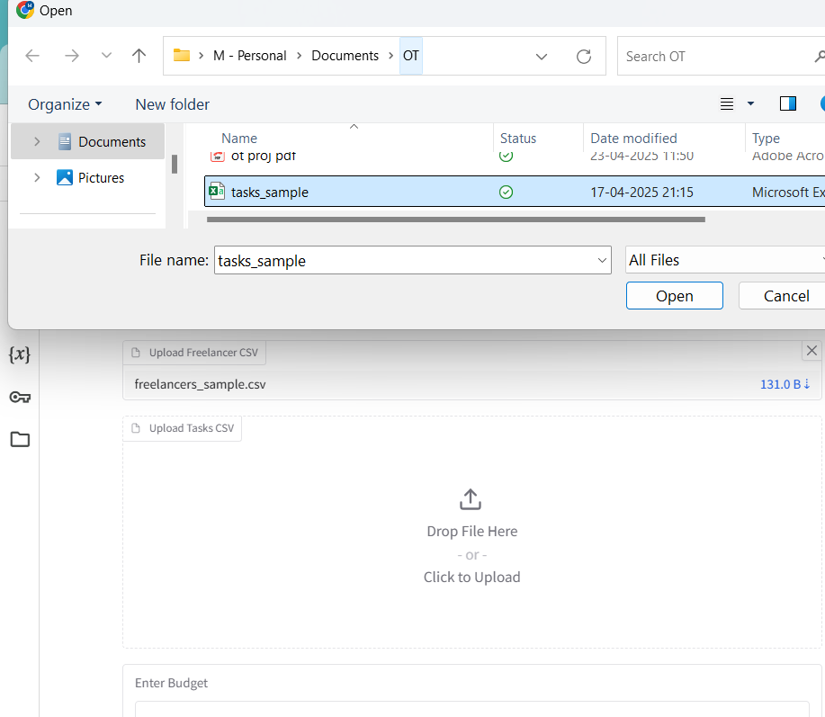
Budget Fixing:
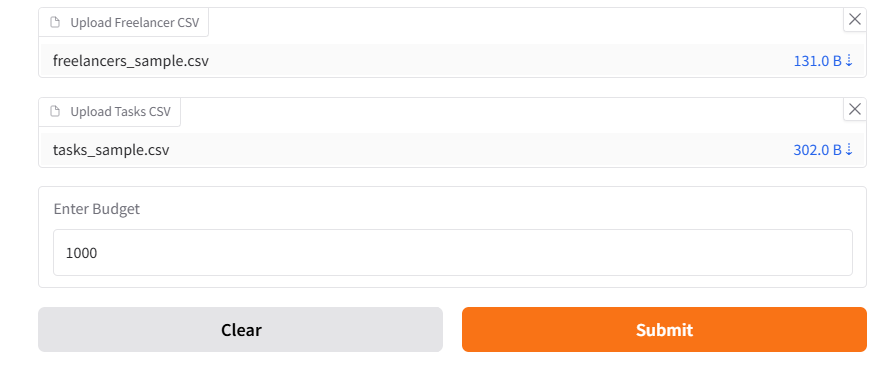
Output:
Assignments:
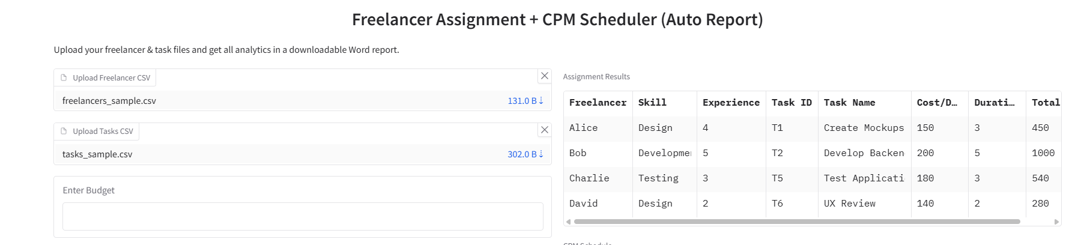
CPM:
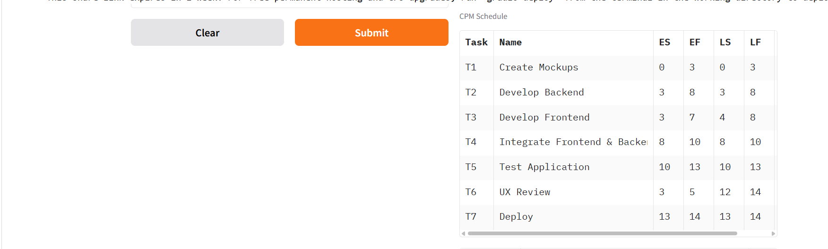
Graph:
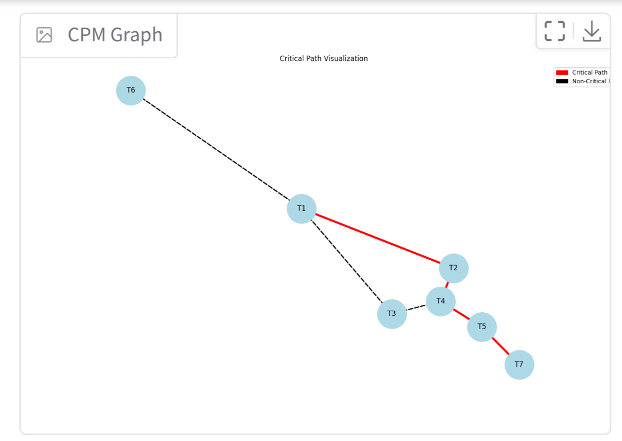
Downloadable:

This downloaded document consists of the dataset ,cost matrix, output(assignment,CPM,dependencies graph) ,total assignment cost , some information whether the assignment is within the budget or not , critical path and duration.
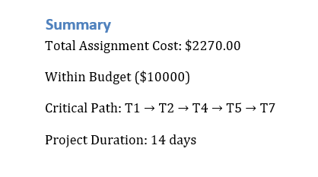

4. Advantages of This System
- Saves time through automatic task assignment and timeline scheduling.
- Minimizes project costs using optimized mathematical algorithms.
- Provides visual clarity with graph-based task flow and critical path highlighting.
- Allows easy export of reports in Word format for documentation and sharing.

5. Real-World Applications
• Construction scheduling
• Freelancing platform automation
• Professors managing research team timelines

6. Results and Discussion
6.1 Optimized Task Assignment
Freelancers were assigned to tasks based on skill and cost using the Hungarian Algorithm, resulting in a cost-efficient assignment table.
6.2 CPM Scheduling
Using task dependencies, the CPM calculated earliest and latest timings. Tasks on the critical path (slack = 0) were highlighted to ensure they’re not delayed.
6.3 Total Project Duration and Critical Path
The total project duration was determined by the longest path through the task dependency graph. These tasks were labeled as critical.
This system provides an end-to-end solution for freelancer assignment and project scheduling using proven optimization techniques. By blending Hungarian Assignment for cost and skill efficiency with CPM for time sensitivity, it ensures robust planning and measurable improvements.

